**MTS9307 Assignment 7 report**

Yu Hu (4909811)

Part 1:

* 1. Summary of the web application

This web application is to help people to find food which they want to eat. People can select their food they want through selecting and narrowing the filters including the categories of “Food kind”, “Size”, “Wait time” and “Price”. Then they just need to click the button named “Find your food!”, the searching result will be presented to them. Then they just need to click “Contact Now” to make phone calls to contact with the relevant food provider. If people do not have any requirements (filters) of selecting food, they can click the button named “Find your food without requirements”, then the whole food record will be presented.

The web application also has an Admin Mode for the admin to manage the data record of food. Admin Mode provides the functions of adding, updating and deleting the data records of food.

* 1. Use cases to present relevant functions

1) Home page functions (filters and browsing)



Figure 1

The figure above shows the Home page of this web application (Figure 1). If A person has no requirements to select the food, he just need to click “Find your food without requirements”, then the entire food record will be presented (Figure 2).

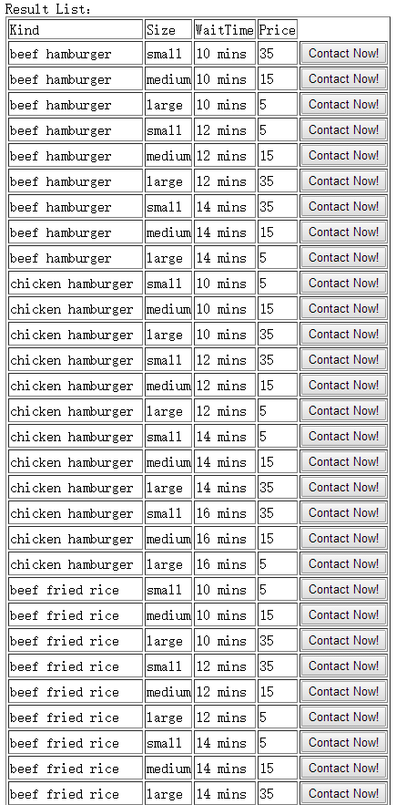

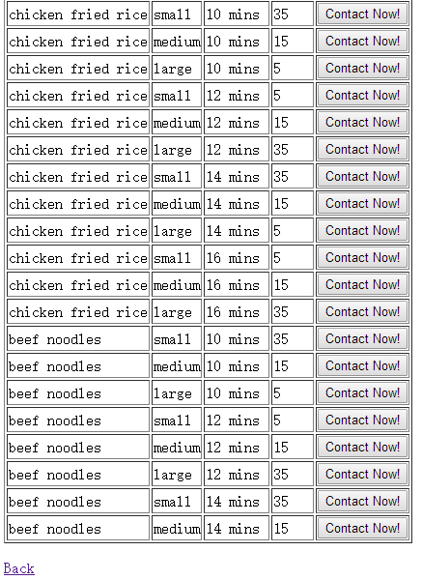

Figure 2

If a person want to find beef hamburger, he needs to select the “chicken hamburger” in “Food kind” then click the button named “Find your food!” Then the search result and the category count will be presented, which are shows in the following figure (Figure 3).

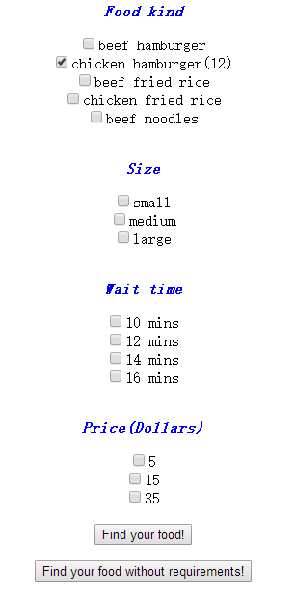

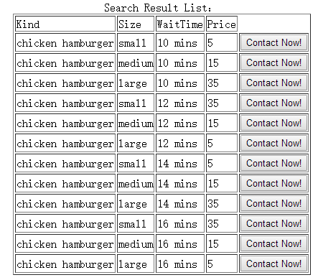

Figure 3

Now, try to narrow the filters. The following figure shows a person who wants to find a small-size chicken hamburger (Figure 4).

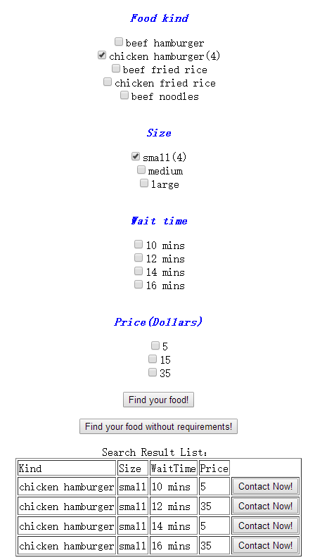

Figure 4

The following figure shows a person who wants to find a 5-dollars small-size chicken hamburger (Figure 5).

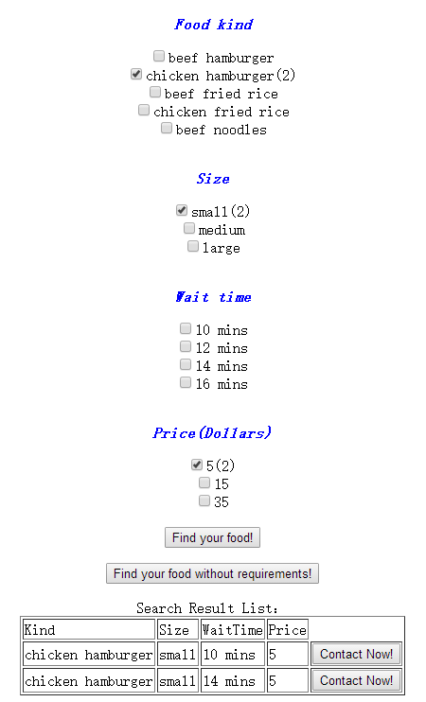

Figure 5

The following figure shows a person who wants to find a 5-dollars small-size chicken hamburger and its wait time is 10 minutes. (Figure 6).

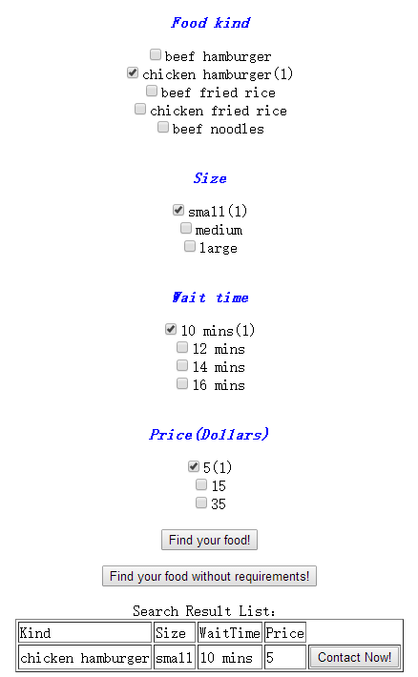

Figure 6

Hence, when narrowing the filters, the users’ prior choices can be saved and presented. Besides, the category counts can be changed and presented correctly.

2) Admin Mode functions (add/update/delete a record, download record log)

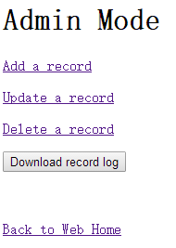

Figure 7

The Admin Mode is presented as Figure 7. The link of “Back to Web Home” links to the home page of the web application. “Add/Update/Delete a record” links to the relevant 3 different interfaces of those functions. The button of “Download record log” allows users to download the record log related to the implementation of adding, updating and deleting records.

**For adding a record:**

For example, add a record of FoodID = f51, Kind = beef noodles, Size= large, waittime=14 mins, Price = 5.

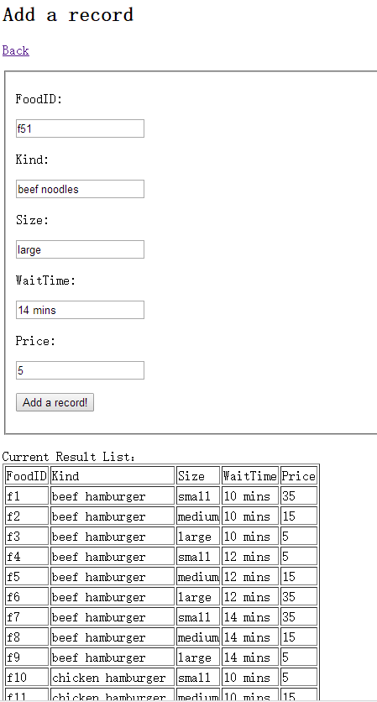

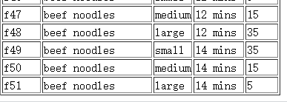

Figure 8

**For updating a record:**

For example, update a record of FoodID = f51, change its wait time to “16 mins”.

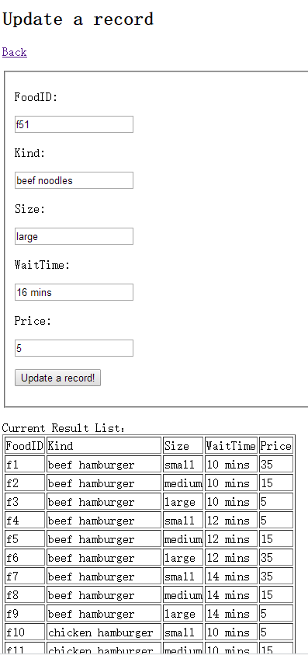

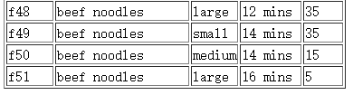

Figure 9

Besides, the users’ prior input value of each attribute can be saved and presented.

**For deleting a record:**

For example, delete a record of FoodID = f51.

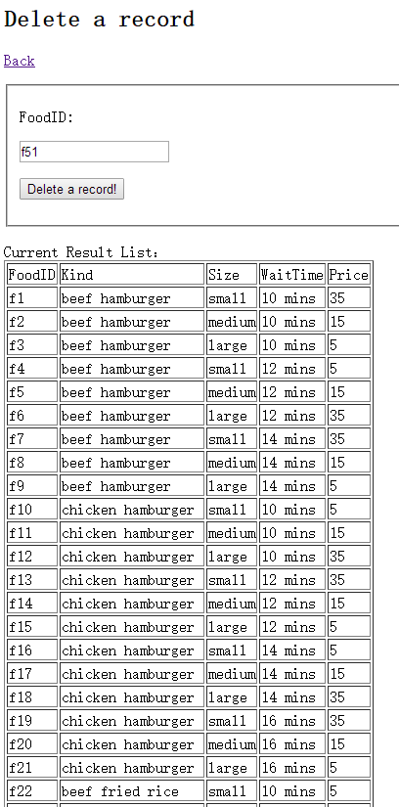

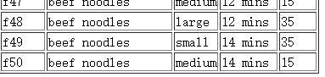

Figure 9

Then the record of FoodID = f51 has been deleted.

**For downloading the record log:**

Now back to home page of Admin Mode, then click “Download record log”, a text file can be downloaded. The following figure shows the content in this text file.

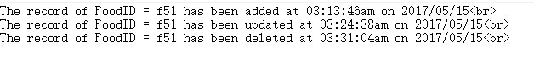

Figure 10

Part 2:

2.1 The configuration setup

The XAMPP Control Panel has been utilized. The detailed information of this are presented through figure 11.

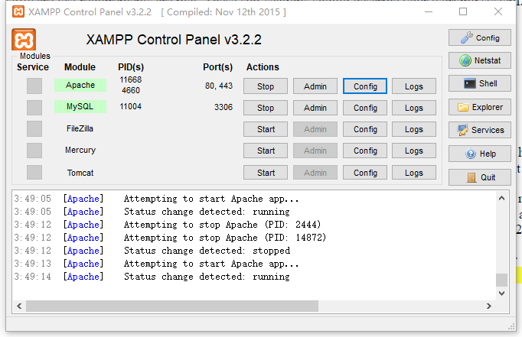

Figure 11

The relevant configuration information of the MySQL server:

[mysqld]

port= 3306

socket = "D:/xampp/mysql/mysql.sock"

basedir = "D:/xampp/mysql"

tmpdir = "D:/xampp/tmp"

datadir = "D:/xampp/mysql/data"

pid_file = "mysql.pid"

# enable-named-pipe

key_buffer = 16M

max_allowed_packet = 1M

sort_buffer_size = 512K

net_buffer_length = 8K

read_buffer_size = 256K

read_rnd_buffer_size = 512K

myisam_sort_buffer_size = 8M

log_error = "mysql_error.log"

# Change here for bind listening

# bind-address="127.0.0.1"

# bind-address = ::1 # for ipv6

# Where do all the plugins live

plugin_dir = "D:/xampp/mysql/lib/plugin/"

2.2 The overview of code and database

The designed code is mainly PHP codes to achieve the functions of faceted search, category counts, add/update/delete the record of database, record logs and so on. Besides, some HML5 and CSS codes are also utilized to change the position of the text and diversify the styles of the fonts so that the interface of the web application can be more interesting. The database is utilized to show the collection of food. There are 5 categories in this collection, which are FoodID, Kind, Size, WaitTime and Price (Figure 12).

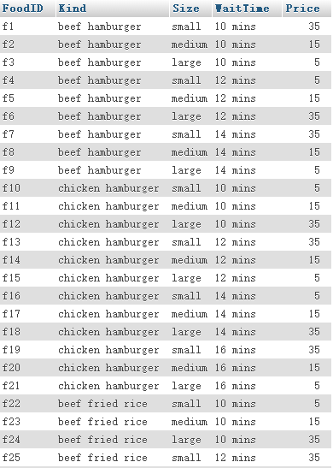

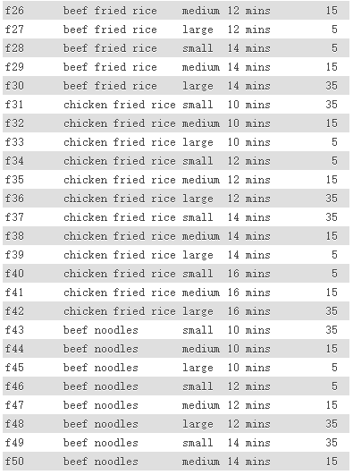

Figure 12

* 1. The codes in detail

(1)The codes in Assign7.php (Home page of the web application)

<html>

<head>

<style>

.div1{color:red};

</style>

</head>

<body>

<a href="Assign7(admin).php">Admin Mode</a>

<p></p>

<div class="div1"><h1><center>Find To Eat</center></h1></div>

<center><img src="/eat2.jpg" /></center>

</body>

<center><form name="f1" action="Assign7.php" method="POST" >

<p style="font-weight:bold;font-style:italic;color:blue;">Food kind</p>

<input type="checkbox" name="c1" value="beef hamburger"<?php if($_SERVER["REQUEST_METHOD"] == "POST"){

if (isset($_POST["c1"])=='beef hamburger')

echo 'checked';

}?>>beef hamburger<?php if($_SERVER["REQUEST_METHOD"] == "POST"){if (isset($_POST["c1"])=='beef hamburger')

showCount();}

?><br>

<input type="checkbox" name="c2" value="chicken hamburger"<?php if($_SERVER["REQUEST_METHOD"] == "POST"){

if (isset($_POST["c2"])=='chicken hamburger')

echo 'checked';

}?>>chicken hamburger<?php if($_SERVER["REQUEST_METHOD"] == "POST"){if (isset($_POST["c2"])=='chicken hamburger')

showCount();}

?><br>

<input type="checkbox" name="c3" value="beef fried rice"<?php if($_SERVER["REQUEST_METHOD"] == "POST"){

if (isset($_POST["c3"])=='beef fried rice')

echo 'checked';

}?>>beef fried rice<?php if($_SERVER["REQUEST_METHOD"] == "POST"){if (isset($_POST["c3"])=='beef fried rice')

showCount();}

?><br>

<input type="checkbox" name="c4" value="chicken fried rice"<?php if($_SERVER["REQUEST_METHOD"] == "POST"){

if (isset($_POST["c4"])=='chicken fried rice')

echo 'checked';

}?>>chicken fried rice<?php if($_SERVER["REQUEST_METHOD"] == "POST"){if (isset($_POST["c4"])=='chicken fried rice')

showCount();}

?><br>

<input type="checkbox" name="c5" value="beef noodles"<?php if($_SERVER["REQUEST_METHOD"] == "POST"){

if (isset($_POST["c5"])=='beef noodles')

echo 'checked';

}?>>beef noodles<?php if($_SERVER["REQUEST_METHOD"] == "POST"){if (isset($_POST["c5"])=='beef noodles')

showCount();}

?><br><br>

<p style="font-weight:bold;font-style:italic;color:blue;">Size</p>

<input type="checkbox" name="c6" value="small"<?php if($_SERVER["REQUEST_METHOD"] == "POST"){

if (isset($_POST["c6"])=='small')

echo 'checked';

}?>>small<?php if($_SERVER["REQUEST_METHOD"] == "POST"){if (isset($_POST["c6"])=='small')

showCount();}

?><br>

<input type="checkbox" name="c7" value="medium"<?php if($_SERVER["REQUEST_METHOD"] == "POST"){

if (isset($_POST["c7"])=='medium')

echo 'checked';

}?>>medium<?php if($_SERVER["REQUEST_METHOD"] == "POST"){if (isset($_POST["c7"])=='medium')

showCount();}

?><br>

<input type="checkbox" name="c8" value="large"<?php if($_SERVER["REQUEST_METHOD"] == "POST"){

if (isset($_POST["c8"])=='large')

echo 'checked';

}?>>large<?php if($_SERVER["REQUEST_METHOD"] == "POST"){if (isset($_POST["c8"])=='large')

showCount();}

?><br><br>

<p style="font-weight:bold;font-style:italic;color:blue;">Wait time</p>

<input type="checkbox" name="c9" value="10 mins"<?php if($_SERVER["REQUEST_METHOD"] == "POST"){

if (isset($_POST["c9"])=='10 mins')

echo 'checked';

}?>>10 mins<?php if($_SERVER["REQUEST_METHOD"] == "POST"){if (isset($_POST["c9"])=='10 mins')

showCount();}

?><br>

<input type="checkbox" name="c10" value="12 mins"<?php if($_SERVER["REQUEST_METHOD"] == "POST"){

if (isset($_POST["c10"])=='12 mins')

echo 'checked';

}?>>12 mins<?php if($_SERVER["REQUEST_METHOD"] == "POST"){if (isset($_POST["c10"])=='12 mins')

showCount();}

?><br>

<input type="checkbox" name="c11" value="14 mins"<?php if($_SERVER["REQUEST_METHOD"] == "POST"){

if (isset($_POST["c11"])=='14 mins')

echo 'checked';

}?>>14 mins<?php if($_SERVER["REQUEST_METHOD"] == "POST"){if (isset($_POST["c11"])=='14 mins')

showCount();}

?><br>

<input type="checkbox" name="c12" value="16 mins"<?php if($_SERVER["REQUEST_METHOD"] == "POST"){

if (isset($_POST["c12"])=='16 mins')

echo 'checked';

}?>>16 mins<?php if($_SERVER["REQUEST_METHOD"] == "POST"){if (isset($_POST["c12"])=='16 mins')

showCount();}

?><br><br>

<p style="font-weight:bold;font-style:italic;color:blue;">Price(Dollars)</p>

<input type="checkbox" name="c13" value="5"<?php if($_SERVER["REQUEST_METHOD"] == "POST"){

if (isset($_POST["c13"])=='5')

echo 'checked';

}?>>5<?php if($_SERVER["REQUEST_METHOD"] == "POST"){if (isset($_POST["c13"])=='5')

showCount();}

?><br>

<input type="checkbox" name="c14" value="15"<?php if($_SERVER["REQUEST_METHOD"] == "POST"){

if (isset($_POST["c14"])=='15')

echo 'checked';

}?>>15<?php if($_SERVER["REQUEST_METHOD"] == "POST"){if (isset($_POST["c14"])=='15')

showCount();}

?><br>

<input type="checkbox" name="c15" value="35"<?php if($_SERVER["REQUEST_METHOD"] == "POST"){

if (isset($_POST["c15"])=='35')

echo 'checked';

}?>>35<?php if($_SERVER["REQUEST_METHOD"] == "POST"){if (isset($_POST["c15"])=='35')

showCount();}

?><br><br>

<input type="submit" value="Find your food!">

</form></center>

<center><form name="form2" action="Assign7(2).php" method="POST" >

<input type = "submit" value="Find your food without requirements!"/>

</form></center>

<?php

$fbf=$fch=$fbfr=$fcfr=$fbn=$ssmall=$smedium=$slarge=$wm10=$wm12=$wm14=$wm16=$price5=$price15=$price35='';

function showCount(){

$fbf=$fch=$fbfr=$fcfr=$fbn=$ssmall=$smedium=$slarge=$wm10=$wm12=$wm14=$wm16=$price5=$price15=$price35='';

$kind=$size=$waittime=$price='';

if (isset($_POST["c1"]))

$fbf=$_POST['c1'];

if (isset($_POST["c2"]))

$fch=$_POST['c2'];

if (isset($_POST["c3"]))

$fbfr=$_POST['c3'];

if (isset($_POST["c4"]))

$fcfr=$_POST['c4'];

if (isset($_POST["c5"]))

$fbn=$_POST['c5'];

if (isset($_POST["c6"]))

$ssmall=$_POST['c6'];

if (isset($_POST["c7"]))

$smedium=$_POST['c7'];

if (isset($_POST["c8"]))

$slarge=$_POST['c8'];

if (isset($_POST["c9"]))

$wm10=$_POST['c9'];

if (isset($_POST["c10"]))

$wm12=$_POST['c10'];

if (isset($_POST["c11"]))

$wm14=$_POST['c11'];

if (isset($_POST["c12"]))

$wm16=$_POST['c12'];

if (isset($_POST["c13"]))

$price5=$_POST['c13'];

if (isset($_POST["c14"]))

$price15=$_POST['c14'];

if (isset($_POST["c15"]))

$price35=$_POST['c15'];

$server_name="localhost";

$user_name="root";

$user_password="";

$database_name="collection";

$table_name="food";

$conn=new mysqli($server_name,$user_name,$user_password,$database_name);

if ($fbf=='beef hamburger')

$kind=$fbf;

else if ($fch=='chicken hamburger')

$kind=$fch;

else if ($fbfr=='beef fried rice')

$kind=$fbfr;

else if ($fcfr=='chicken fried rice')

$kind=$fcfr;

else if ($fbn=='beef noodles')

$kind=$fbn;

if ($ssmall=='small')

$size=$ssmall;

else if ($smedium=='medium')

$size=$smedium;

else if ($slarge=='large')

$size=$slarge;

if ($wm10=='10 mins')

$waittime=$wm10;

else if ($wm12=='12 mins')

$waittime=$wm12;

else if ($wm14=='14 mins')

$waittime=$wm14;

else if ($wm16=='16 mins')

$waittime=$wm16;

if ($price5=='5')

$price=$price5;

else if ($price15=='15')

$price=$price15;

else if ($price35=='35')

$price=$price35;

if ($kind ==! null && $size ==! null && $waittime ==! null && $price ==! null){

$res = mysqli_query($conn,"SELECT COUNT(*) FROM food WHERE Kind = '$kind' and Size = '$size' and WaitTime = '$waittime' and Price = '$price'");}

else if ($kind == null && $size == null && $waittime == null){

$res = mysqli_query($conn,"SELECT COUNT(*) FROM food WHERE Price = '$price'");

}

else if ($kind == null && $size == null && $price == null){

$res = mysqli_query($conn,"SELECT COUNT(*) FROM food WHERE WaitTime = '$waittime'");}

else if ($kind == null && $waittime == null && $price == null){

$res = mysqli_query($conn,"SELECT COUNT(*) FROM food WHERE Size = '$size'");}

else if ($size == null && $waittime == null && $price == null){

$res = mysqli_query($conn,"SELECT COUNT(*) FROM food WHERE Kind = '$kind'");}

else if ($kind == null && $size == null){

$res = mysqli_query($conn,"SELECT COUNT(*) FROM food WHERE WaitTime = '$waittime' and Price = '$price'");}

else if ($kind == null && $waittime == null){

$res = mysqli_query($conn,"SELECT COUNT(*) FROM food WHERE Size = '$size'

and Price = '$price'");}

else if ($kind == null && $price == null){

$res = mysqli_query($conn,"SELECT COUNT(*) FROM food WHERE Size = '$size'

and WaitTime = '$waittime'");}

else if ($size == null && $waittime == null){

$res = mysqli_query($conn,"SELECT COUNT(*) FROM food WHERE Kind = '$kind'

and Price = '$price'");}

else if ($size == null && $price == null){

$res = mysqli_query($conn,"SELECT COUNT(*) FROM food WHERE Kind = '$kind'

and WaitTime = '$waittime'");}

else if ($waittime == null && $price == null){

$res = mysqli_query($conn,"SELECT COUNT(*) FROM food WHERE Kind = '$kind' and Size = '$size'");}

else if ($kind == null){

$res = mysqli_query($conn,"SELECT COUNT(*) FROM food WHERE Size = '$size'

and WaitTime = '$waittime' and Price = '$price'");}

else if ($size == null){

$res = mysqli_query($conn,"SELECT COUNT(*) FROM food WHERE Kind = '$kind'

and WaitTime = '$waittime' and Price = '$price'");}

else if ($waittime == null){

$res = mysqli_query($conn,"SELECT COUNT(*) FROM food WHERE Kind = '$kind' and Size = '$size'

and Price = '$price'"); }

else if ($price == null){

$res = mysqli_query($conn,"SELECT COUNT(*) FROM food WHERE Kind = '$kind' and Size = '$size'

and WaitTime = '$waittime'");}

$row=mysqli_fetch_array($res);

echo "(".$row[0].")";

}

function showResult1(){

$server_name="localhost";

$user_name="root";

$user_password="";

$database_name="collection";

$table_name="food";

$conn=new mysqli($server_name,$user_name,$user_password,$database_name);

$res = mysqli_query($conn,"SELECT * FROM collection.food");

echo "Result List：";

echo "<table border=1>";

echo "<tr><td>Kind</td><td>Size</td><td>WaitTime</td><td>Price</td></tr>";

while($row=mysqli_fetch_array($res))

{

echo "<tr>";

echo "<td>".$row["Kind"]." </td>";

echo "<td>".$row["Size"]." </td>";

echo "<td>".$row["WaitTime"]." </td>";

echo "<td>".$row["Price"]." </td>";

echo "</tr>";

}

echo "</table>";

}

function showResult3(){

$fbf=$fch=$fbfr=$fcfr=$fbn=$ssmall=$smedium=$slarge=$wm10=$wm12=$wm14=$wm16=$price5=$price15=$price35='';

$kind=$size=$waittime=$price='';

if (isset($_POST["c1"]))

$fbf=$_POST['c1'];

if (isset($_POST["c2"]))

$fch=$_POST['c2'];

if (isset($_POST["c3"]))

$fbfr=$_POST['c3'];

if (isset($_POST["c4"]))

$fcfr=$_POST['c4'];

if (isset($_POST["c5"]))

$fbn=$_POST['c5'];

if (isset($_POST["c6"]))

$ssmall=$_POST['c6'];

if (isset($_POST["c7"]))

$smedium=$_POST['c7'];

if (isset($_POST["c8"]))

$slarge=$_POST['c8'];

if (isset($_POST["c9"]))

$wm10=$_POST['c9'];

if (isset($_POST["c10"]))

$wm12=$_POST['c10'];

if (isset($_POST["c11"]))

$wm14=$_POST['c11'];

if (isset($_POST["c12"]))

$wm16=$_POST['c12'];

if (isset($_POST["c13"]))

$price5=$_POST['c13'];

if (isset($_POST["c14"]))

$price15=$_POST['c14'];

if (isset($_POST["c15"]))

$price35=$_POST['c15'];

$server_name="localhost";

$user_name="root";

$user_password="";

$database_name="collection";

$table_name="food";

$conn=new mysqli($server_name,$user_name,$user_password,$database_name);

if ($fbf=='beef hamburger')

$kind=$fbf;

else if ($fch=='chicken hamburger')

$kind=$fch;

else if ($fbfr=='beef fried rice')

$kind=$fbfr;

else if ($fcfr=='chicken fried rice')

$kind=$fcfr;

else if ($fbn=='beef noodles')

$kind=$fbn;

if ($ssmall=='small')

$size=$ssmall;

else if ($smedium=='medium')

$size=$smedium;

else if ($slarge=='large')

$size=$slarge;

if ($wm10=='10 mins')

$waittime=$wm10;

else if ($wm12=='12 mins')

$waittime=$wm12;

else if ($wm14=='14 mins')

$waittime=$wm14;

else if ($wm16=='16 mins')

$waittime=$wm16;

if ($price5=='5')

$price=$price5;

else if ($price15=='15')

$price=$price15;

else if ($price35=='35')

$price=$price35;

if ($kind ==! null && $size ==! null && $waittime ==! null && $price ==! null){

$res = mysqli_query($conn,"SELECT * FROM food WHERE Kind = '$kind' and Size = '$size'

and WaitTime = '$waittime' and Price = '$price'");}

else if ($kind == null && $size == null && $waittime == null){

$res = mysqli_query($conn,"SELECT * FROM food WHERE Price = '$price'");}

else if ($kind == null && $size == null && $price == null){

$res = mysqli_query($conn,"SELECT * FROM food WHERE WaitTime = '$waittime'");}

else if ($kind == null && $waittime == null && $price == null){

$res = mysqli_query($conn,"SELECT * FROM food WHERE Size = '$size'");}

else if ($size == null && $waittime == null && $price == null){

$res = mysqli_query($conn,"SELECT * FROM food WHERE Kind = '$kind'");}

else if ($kind == null && $size == null){

$res = mysqli_query($conn,"SELECT * FROM food WHERE WaitTime = '$waittime' and Price = '$price'");}

else if ($kind == null && $waittime == null){

$res = mysqli_query($conn,"SELECT * FROM food WHERE Size = '$size'

and Price = '$price'");}

else if ($kind == null && $price == null){

$res = mysqli_query($conn,"SELECT * FROM food WHERE Size = '$size'

and WaitTime = '$waittime'");}

else if ($size == null && $waittime == null){

$res = mysqli_query($conn,"SELECT * FROM food WHERE Kind = '$kind'

and Price = '$price'");}

else if ($size == null && $price == null){

$res = mysqli_query($conn,"SELECT * FROM food WHERE Kind = '$kind'

and WaitTime = '$waittime'");}

else if ($waittime == null && $price == null){

$res = mysqli_query($conn,"SELECT * FROM food WHERE Kind = '$kind' and Size = '$size'");}

else if ($kind == null){

$res = mysqli_query($conn,"SELECT * FROM food WHERE Size = '$size'

and WaitTime = '$waittime' and Price = '$price'");}

else if ($size == null){

$res = mysqli_query($conn,"SELECT * FROM food WHERE Kind = '$kind'

and WaitTime = '$waittime' and Price = '$price'");}

else if ($waittime == null){

$res = mysqli_query($conn,"SELECT * FROM food WHERE Kind = '$kind' and Size = '$size'

and Price = '$price'"); }

else if ($price == null){

$res = mysqli_query($conn,"SELECT * FROM food WHERE Kind = '$kind' and Size = '$size'

and WaitTime = '$waittime'");}

echo "<center>Search Result List：</center>";

echo "<center><table border=1>";

echo "<tr><td>Kind</td><td>Size</td><td>WaitTime</td><td>Price</td></tr>";

while($row=mysqli_fetch_array($res))

{

echo "<tr>";

echo "<td>".$row["Kind"]." </td>";

echo "<td>".$row["Size"]." </td>";

echo "<td>".$row["WaitTime"]." </td>";

echo "<td>".$row["Price"]." </td>";

echo "<td><button>Contact Now!</button></td>";

echo "</tr>";

}

echo "</table></center>";

}

if($_SERVER["REQUEST_METHOD"] == "POST"){

if (isset($_POST["c1"]))

$fbf=$_POST['c1'];

if (isset($_POST["c2"]))

$fch=$_POST['c2'];

if (isset($_POST["c3"]))

$fbfr=$_POST['c3'];

if (isset($_POST["c4"]))

$fcfr=$_POST['c4'];

if (isset($_POST["c5"]))

$fbn=$_POST['c5'];

if (isset($_POST["c6"]))

$ssmall=$_POST['c6'];

if (isset($_POST["c7"]))

$smedium=$_POST['c7'];

if (isset($_POST["c8"]))

$slarge=$_POST['c8'];

if (isset($_POST["c9"]))

$wm10=$_POST['c9'];

if (isset($_POST["c10"]))

$wm12=$_POST['c10'];

if (isset($_POST["c11"]))

$wm14=$_POST['c11'];

if (isset($_POST["c12"]))

$wm16=$_POST['c12'];

if (isset($_POST["c13"]))

$price5=$_POST['c13'];

if (isset($_POST["c14"]))

$price15=$_POST['c14'];

if (isset($_POST["c15"]))

$price35=$_POST['c15'];

showResult3();

}

?>

</html>

(2)The codes in Assign7(2).php (the search result without any filter selected)

<html>

<body>

<?php

function showResult1(){

$server_name="localhost";

$user_name="root";

$user_password="";

$database_name="collection";

$table_name="food";

$conn=new mysqli($server_name,$user_name,$user_password,$database_name);

$res = mysqli_query($conn,"SELECT * FROM collection.food");

echo "Result List：";

echo "<table border=1>";

echo "<tr><td>Kind</td><td>Size</td><td>WaitTime</td><td>Price</td></tr>";

while($row=mysqli_fetch_array($res))

{

echo "<tr>";

echo "<td>".$row["Kind"]." </td>";

echo "<td>".$row["Size"]." </td>";

echo "<td>".$row["WaitTime"]." </td>";

echo "<td>".$row["Price"]." </td>";

echo "<td><button>Contact Now!</button></td>";

echo "</tr>";

}

echo "</table>";

}

showResult1();

?>

<p></p>

<a href="Assign7.php">Back</a>

</body>

</html>

(3)The codes in Assign7(admin).php (the home page of Admin Mode)

<html>

<body>

<h1>Admin Mode</h1>

<p></p>

<a href="Assign7(admin1).php">Add a record</a>

<p></p>

<a href="Assign7(admin2).php">Update a record</a>

<p></p>

<a href="Assign7(admin3).php">Delete a record</a>

<p></p>

<form name="f3" action="log.php">

<input type = "submit" value="Download record log"/>

</form>

<br /><br />

<a href="Assign7.php">Back to Web Home</a>

</body>

</html>

(4)The codes in Assign7(admin1).php (the page of adding a record)

<html>

<body>

<h1>Admin Mode</h1>

<h2>Add a record</h2>

<a href="Assign7(admin).php">Back</a>

<p></p>

<?php

date_default_timezone_set("Australia/Sydney");

$myfile = fopen("recordlog.txt", "a+");

$fid = "";

$kind = "";

$size = "";

$waittime = "";

$price = "";

$server_name="localhost";

$user_name="root";

$user_password="";

$database_name="collection";

$table_name="food";

$conn=new mysqli($server_name,$user_name,$user_password,$database_name);

if($_SERVER["REQUEST_METHOD"] == "POST"){

if (isset($_POST["f1"]))

$fid=$_POST['f1'];

if (isset($_POST["k1"]))

$kind=$_POST['k1'];

if (isset($_POST["s1"]))

$size=$_POST['s1'];

if (isset($_POST["w1"]))

$waittime=$_POST['w1'];

if (isset($_POST["p1"]))

$price=$_POST['p1'];

$server_name="localhost";

$user_name="root";

$user_password="";

$database_name="collection";

$table_name="food";

$conn=new mysqli($server_name,$user_name,$user_password,$database_name);

$sql1 = mysqli_query($conn,"INSERT INTO food VALUES ('$fid', '$kind', '$size', '$waittime','$price')");

$myfile = fopen("recordlog.txt", "a+");

$np='The record of FoodID = '.$fid.' has been added at '.date("h:i:sa").' on '.date("Y/m/d").'<br>';

$txt=$np;

fwrite($myfile, $txt);

fclose($myfile);

}

function showResult1(){

$server_name="localhost";

$user_name="root";

$user_password="";

$database_name="collection";

$table_name="food";

$conn=new mysqli($server_name,$user_name,$user_password,$database_name);

$res = mysqli_query($conn,"SELECT * FROM collection.food");

echo "Current Result List：";

echo "<table border=1>";

echo "<tr><td>FoodID</td><td>Kind</td><td>Size</td><td>WaitTime</td><td>Price</td></tr>";

while($row=mysqli_fetch_array($res))

{

echo "<tr>";

echo "<td>".$row["FoodID"]." </td>";

echo "<td>".$row["Kind"]." </td>";

echo "<td>".$row["Size"]." </td>";

echo "<td>".$row["WaitTime"]." </td>";

echo "<td>".$row["Price"]." </td>";

echo "</tr>";

}

echo "</table>";

}

?>

<form name="f1" action="Assign7(admin1).php" method="POST" >

<fieldset>

<p>FoodID:</p>

<input type="text" name="f1" value="<?php echo $fid ;?>" />

<p>Kind:</p>

<input type="text" name="k1" value="<?php echo $kind;?>"/>

<p>Size:</p>

<input type="text" name="s1" value="<?php echo $size;?>" />

<p>WaitTime:</p>

<input type="text" name="w1" value="<?php echo $waittime;?>" />

<p>Price:</p>

<input type="number" name="p1" value="<?php echo $price;?>" />

<p>

<input type="submit" name="sub1" value="Add a record!"/>

</p>

</fieldset>

</form>

<?php

showResult1();

?>

</body>

</html>

(5)The codes in Assign7(admin2).php (the page of updating a record)

<html>

<body>

<h1>Admin Mode</h1>

<h2>Update a record</h2>

<a href="Assign7(admin).php">Back</a>

<p></p>

<?php

date_default_timezone_set("Australia/Sydney");

$myfile = fopen("recordlog.txt", "a+");

$fid = "";

$kind = "";

$size = "";

$waittime = "";

$price = "";

$server_name="localhost";

$user_name="root";

$user_password="";

$database_name="collection";

$table_name="food";

$conn=new mysqli($server_name,$user_name,$user_password,$database_name);

if($_SERVER["REQUEST_METHOD"] == "POST"){

if (isset($_POST["f1"]))

$fid=$_POST['f1'];

if (isset($_POST["k1"]))

$kind=$_POST['k1'];

if (isset($_POST["s1"]))

$size=$_POST['s1'];

if (isset($_POST["w1"]))

$waittime=$_POST['w1'];

if (isset($_POST["p1"]))

$price=$_POST['p1'];

$server_name="localhost";

$user_name="root";

$user_password="";

$database_name="collection";

$table_name="food";

$conn=new mysqli($server_name,$user_name,$user_password,$database_name);

$sql1 = mysqli_query($conn,"UPDATE food SET Kind = '$kind', Size='$size', WaitTime='$waittime', Price='$price' WHERE FoodID = '$fid'");

$myfile = fopen("recordlog.txt", "a+");

$np='The record of FoodID = '.$fid.' has been updated at '.date("h:i:sa").' on '.date("Y/m/d").'<br>';

$txt=$np;

fwrite($myfile, $txt);

fclose($myfile);

}

function showResult1(){

$server_name="localhost";

$user_name="root";

$user_password="";

$database_name="collection";

$table_name="food";

$conn=new mysqli($server_name,$user_name,$user_password,$database_name);

$res = mysqli_query($conn,"SELECT * FROM collection.food");

echo "Current Result List：";

echo "<table border=1>";

echo "<tr><td>FoodID</td><td>Kind</td><td>Size</td><td>WaitTime</td><td>Price</td></tr>";

while($row=mysqli_fetch_array($res))

{

echo "<tr>";

echo "<td>".$row["FoodID"]." </td>";

echo "<td>".$row["Kind"]." </td>";

echo "<td>".$row["Size"]." </td>";

echo "<td>".$row["WaitTime"]." </td>";

echo "<td>".$row["Price"]." </td>";

echo "</tr>";

}

echo "</table>";

}

?>

<form name="f1" action="Assign7(admin2).php" method="POST" >

<fieldset>

<p>FoodID:</p>

<input type="text" name="f1" value="<?php echo $fid ;?>" />

<p>Kind:</p>

<input type="text" name="k1" value="<?php echo $kind;?>"/>

<p>Size:</p>

<input type="text" name="s1" value="<?php echo $size;?>" />

<p>WaitTime:</p>

<input type="text" name="w1" value="<?php echo $waittime;?>" />

<p>Price:</p>

<input type="number" name="p1" value="<?php echo $price;?>" />

<p>

<input type="submit" name="sub1" value="Update a record!"/>

</p>

</fieldset>

</form>

<?php

showResult1();

?>

</body>

</html>

(6)The codes in Assign7(admin3).php (the page of deleting a record)

<html>

<body>

<h1>Admin Mode</h1>

<h2>Delete a record</h2>

<a href="Assign7(admin).php">Back</a>

<p></p>

<?php

date_default_timezone_set("Australia/Sydney");

$myfile = fopen("recordlog.txt", "a+");

$fid = "";

$kind = "";

$size = "";

$waittime = "";

$price = "";

$server_name="localhost";

$user_name="root";

$user_password="";

$database_name="collection";

$table_name="food";

$conn=new mysqli($server_name,$user_name,$user_password,$database_name);

if($_SERVER["REQUEST_METHOD"] == "POST"){

if (isset($_POST["f1"]))

$fid=$_POST['f1'];

if (isset($_POST["k1"]))

$kind=$_POST['k1'];

if (isset($_POST["s1"]))

$size=$_POST['s1'];

if (isset($_POST["w1"]))

$waittime=$_POST['w1'];

if (isset($_POST["p1"]))

$price=$_POST['p1'];

$server_name="localhost";

$user_name="root";

$user_password="";

$database_name="collection";

$table_name="food";

$conn=new mysqli($server_name,$user_name,$user_password,$database_name);

$sql1 = mysqli_query($conn,"DELETE FROM food WHERE FoodID = '$fid'");

$myfile = fopen("recordlog.txt", "a+");

$np='The record of FoodID = '.$fid.' has been deleted at '.date("h:i:sa").' on '.date("Y/m/d").'<br>';

$txt=$np;

fwrite($myfile, $txt);

fclose($myfile);

}

function showResult1(){

$server_name="localhost";

$user_name="root";

$user_password="";

$database_name="collection";

$table_name="food";

$conn=new mysqli($server_name,$user_name,$user_password,$database_name);

$res = mysqli_query($conn,"SELECT * FROM collection.food");

echo "Current Result List：";

echo "<table border=1>";

echo "<tr><td>FoodID</td><td>Kind</td><td>Size</td><td>WaitTime</td><td>Price</td></tr>";

while($row=mysqli_fetch_array($res))

{

echo "<tr>";

echo "<td>".$row["FoodID"]." </td>";

echo "<td>".$row["Kind"]." </td>";

echo "<td>".$row["Size"]." </td>";

echo "<td>".$row["WaitTime"]." </td>";

echo "<td>".$row["Price"]." </td>";

echo "</tr>";

}

echo "</table>";

}

?>

<form name="f1" action="Assign7(admin3).php" method="POST" >

<fieldset>

<p>FoodID:</p>

<input type="text" name="f1" value="<?php echo $fid ;?>" />

<p>

<input type="submit" name="sub1" value="Delete a record!"/>

</p>

</fieldset>

</form>

<?php

showResult1();

?>

</body>

</html>

(7)The codes in log.php (the relevant codes of downloading the record log)

<?php

$file="data/log.txt";

header('Content-type: text/plain');

header('Content-Disposition: attachment; filename="recordlog.txt"');

readfile('recordlog.txt');

?>

2.4 Reflection

On May 11th:

It was time to start the coding of web assignment 7. The objective of this assignment is to create a web application which meets several functions. This application needs to be based on one of the collections. Hence, in my opinion, I needed to create the database of this collection first. Since I had decided to make a web application to help people to find food to eat in previous web programming lessons, so I started creating a table of the collection of food in Excel and saved as a csv file. I made 4 attributes in this food collection including FoodID, Kind, Size, WaitTime and Price. The whole item number of this food collection was 50.

On May 12th:

After I created the food collection in database, I wanted to establish the faceted search engine. I created the home page of my web application with the simple interface. Then I made 4 part for 4 different attributes, which were Food kind, Size, Wait time and Price (Dollars). In each attribute, there listed the different categories. Then I put a checkbox in the left side of each category for being ticked by the application users in future. I put 2 buttons on the bottom of the last attribute, one was for faceted searching with requirements (has filter), and the other one is for without requirements (no filter). The next thing I wanted to do is to achieve the function of showing the search result without any filter. I created the codes for reading the database of food collection, but then one problem occurred. The problem was that I could not show the result of all items of the collection with the form of a table. After I checked the lecture notes and discussed with my friend, I knew that I needed to make a function to print this table. In this function, firstly I needed to read the data from the database of the food collection. Secondly, I needed to define a variable named $res to define the result of one SQL call, such as “SELECT * FROM food” (The table name is food), to select the whole data of the food collection. Thirdly, I needed to use “echo” to present the table and use “while” loop. In “while” loop, the codes like “while ($row= mysqli_fetch_array ($res))” and used “echo” and “$row[“Kind”]” to show the value of the attribute named Kind. Hence, the other attributes like Size, WaitTime and Price could also use this method to show their value in the database. Finally, I named this function as “showResult1”, and made a form button named as “Find your food without requirements!” to call this function after the user click this button. This means after the user click this button, the search result of no filter selected will be presented as the form of a table.

On May 13th:

Today, I decided to create the Admin Mode for my web application. The admin Mode was to add, update and delete the record of the food collection in database. Hence, today I decided to complete the function of adding the record first. I created a simple home page of the Admin Mode. There were 4 links in this page, which were “Add a record”, “update a record”, “Delete a record” and “Back to Web Home”. The link of “Add a record” was to link to the page of adding a record. The link of “Update a record” was to link to the page of updating a record. The link of “Delete a record” was to link to the page of deleting a record. The link of “Back to Web Home” is to link to the home page of the Admin Mode. In the page of updating a record, I used a form, some texts and textboxes to present the attributes that needed to be entered by the user. In the bottom of the form, I presented the current food collection which was shown in a table. This content of table would be changed after each operation of adding, updating or deleting a record. Then I succeeded in writing the codes of achieving function of adding a record. However, one problem occurred. The problem was that after I entered the value in each textbox of each attribute and then click “Add a record!”, those values I had entered had not been saved. They needed to be still presented in the textboxes. After I discussed with my friends, I knew that I needed to use, such as “<?php echo $size; ?> ” in the value of each text. For example, <input type="text" name="s1" value="<?php echo $size;?>" />. Then the values which were entered by the user can be saved after submitting the form.

On May 14th:

After I completed to achieve the function of adding a record, I decided to achieve another two functions which were updating and deleting a record. I created a page of updating a record, and a form, which was just like the form of adding a record I had made on May 14th. Then I wrote the codes to achieve the function of updating the record. However, it failed. After I checked my codes and searched the relevant information from the Internet, I knew that I had made mistake in writing the SQL to call for the function of updating. I had written “UPDATE food FROM kind= ‘$kind’……”. However, the correct SQL was that “UPDATE food SET kind= ‘$kind’……”. It was “SET” not “FROM”. I thought it was a careless mistake. After I corrected this, the function went correct. Then I created a page of deleting a record, and a form, which was like the form of adding and updating a record. The difference was that there was only one value of the attribute “FoodID” to be entered by the user, which would be convenient for the user to operate this function.

On May 15th:

After I completed to achieve the functions of adding, updating and deleting a record, I decided to achieve the function of creating the record log for each of the above function. I added some codes, such as “$myfile = fopen("recordlog.txt", "a+");” to create or open recordlog.txt and “'The record of FoodID = '.$fid.' has been added.'<br>';” to show the text in the recordlog.txt. The content of text in recordlog.txt was just like “The record of FoodID = f51 has been added”. However, the problem was that I wanted to present the exact time when the user update, add or delete a record. After I search the Internet, I knew that I could use “date_default_timezone_set("Australia/Sydney");” to define the local time first, and then use like “'The record of FoodID = '.$fid.' has been added at '.date("h:i:sa").' on '.date("Y/m/d").'<br>';” to present. Hence, after I revised my codes, the contents in recordlog.txt were presented like “The record of FoodID = f51 has been added at 03:13:46am on 2017/05/16”. This would be more comfortable and convenient for the admin to know the detailed situation of changing the record. Finally, I made one button to download this recordlog.txt in the home page of Admin Mode.

On May 16th:

Today, I decided to complete this web application, but first was to make codes of the core part of this web application, which was to achieve the function of faceted search and the faceted search counts. I finished to write the codes of faceted search quite fast because I had done similar things in the previous assignments. However, how to count the faceted search for each category and present these count numbers confused me a lot. After I discussed with my friends and searched the Internet, I knew that the SQL call like “SELECT COUNT(*) FROM food WHERE ……” can be used to count the faceted search for each category and using “mysqli_fetch_array” and other functions to present those count numbers besides each category like “beef hamburger(9)”. To my surprise, I had not spent too much time on the whole progress of writing codes of these 2 core functions, but I really learned much new knowledge like how to count use SQL calls and so on. Finally, I used some CSS codes to change some text positions, diversified the styles of the fonts and inserted a picture of someone eating so that the interface of the web application could be nice and interesting.

In conclusion, after I completed all the functions and requirements of the standard level of Assignment 7, I find that although sometimes it was very hard to find the solution to create the codes to achieve some functions, but when I found the solution, I felt very happy and enjoyed this great benefit. The benefit is that next time the entire coding of the process can be more efficient and I could avoid detours and save time in code making. This is because I have already known the solutions to achieve some functions, such as how to present the data in database as a form of a table, how to achieve the functions of faceted search and counting, how to update something by using the correct SQL call, how to show date information in the record log and so on. Besides, next time the whole process can be more logical, for example, complete the coding of Admin Mode first or home page of the web application first, rather than do something in Admin Mode and then do something in home page of the web application. This would make the process in a mess.